SMC Viveka — Technical Documentation
AI Conversation Intelligence Agent for SMC Insurance
Model: GLM-4.7-Flash • Stack: Node.js + Express + PostgreSQL • Frontend: HTML/CSS/JS

1. Overview
SMC Viveka stores call recordings and their auto-generated transcripts. The platform used to require staff to scroll and filter through hundreds of rows to find a specific call log, and performance reviews meant reading raw metrics by hand.
The AI agent removes that friction. A user asks a question in plain English in the chat window; the agent works out what data is needed, fetches it, and replies in clean spoken language — while the dashboard updates with the matching charts (call volume, sentiment, CSAT, etc.).

What it solves
- No more manual scrolling and filtering of 100s of rows to find a specific call log.
- Instant summaries of how an agent performed across a day or a week.
- Sentiment and CSAT delivered conversationally, not just as static numbers.

2. Architecture at a glance
The agent acts as a translator between human language and the database. It uses the GLM model twice — first to understand the question, then to write the answer — with a cache and the database sitting in the middle to keep answers fast and accurate.

3. Components
1. Frontend (Chat UI + Dashboard) — Plain HTML, CSS and JavaScript. index.html + app.js render the chat window; dashboard.html renders the visualizations (top agents, sentiment, duration, callbacks, leads). The user types naturally — no filters or SQL.
2. Backend API — A Node.js + Express server on port 3001. The single entry point is POST /api/chat, which coordinates intent detection, caching, the data lookup, and the final reply.
3. GLM Router (AI call 1) — GLM-4.7-Flash is prompted as a strict data router: it reads the user message and returns only a small JSON object — an intent plus parameters (e.g. { intent: “get_calls_by_agent”, params: { agent_name: “Gaurav” } }). Low temperature keeps it deterministic.
4. Cache Layer — An in-memory node-cache (no Docker, zero setup). Two caches: one for detected intents (same wording → same intent) and one for query results. On a hit, the answer returns in well under a millisecond and the database + AI steps are skipped.
5. Data Layer — On a miss, the server queries the data source. PostgreSQL on AWS RDS holds production data; during testing the agent reads the JSON call files in test_data/. Results are trimmed (top 10–15 rows) and then written into the cache for next time.
6. GLM Responder (AI call 2) — GLM-4.7-Flash is called again with the original question plus the raw rows, and asked to summarize them clearly and professionally. This produces the human-readable reply.
7. Response to UI — The backend returns { reply, data, intent, cached }. The chat shows the reply and the dashboard re-renders the relevant charts.

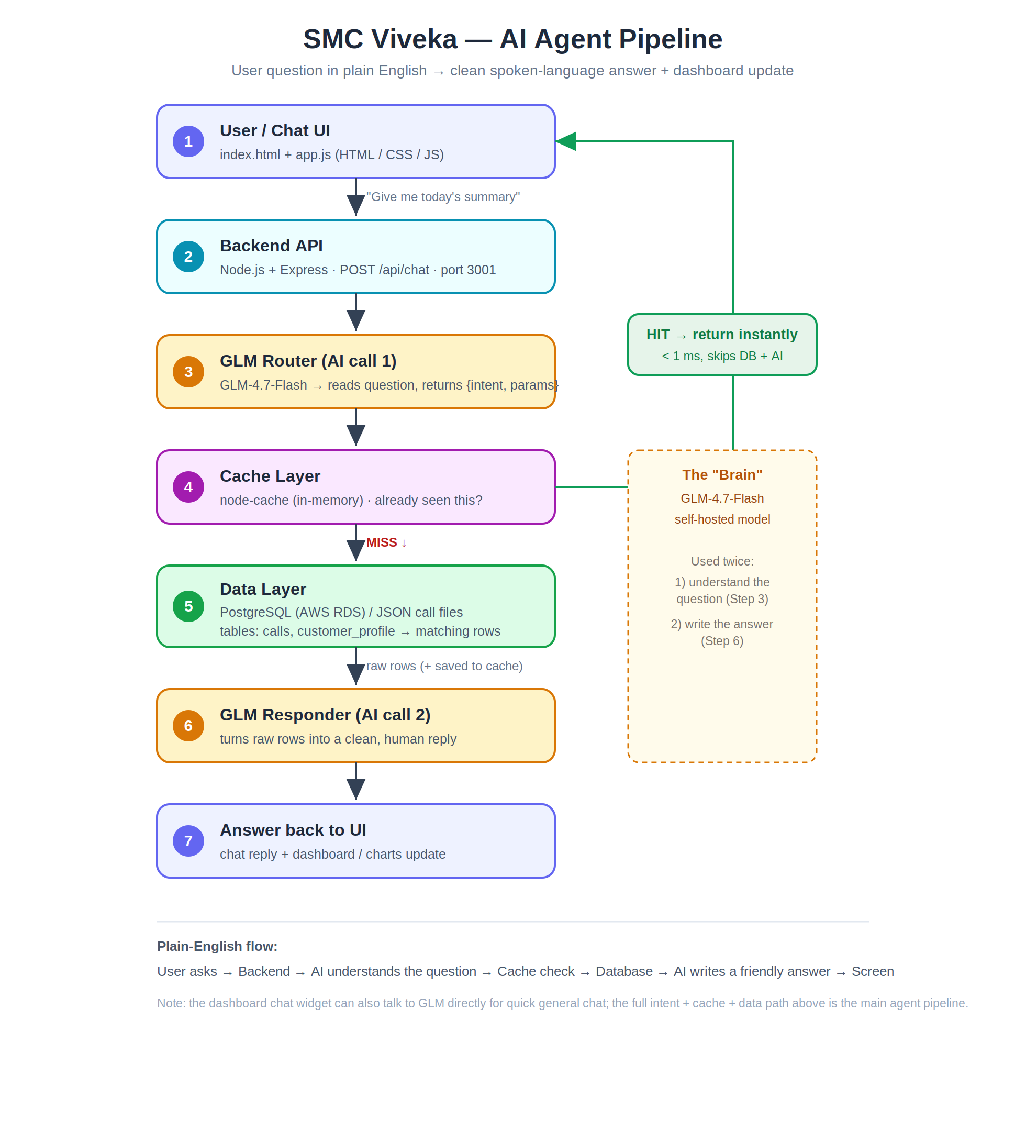

4. Request lifecycle (worked example)
User types: “Show me Gaurav’s calls”
- The chat UI sends the message to POST /api/chat.
- Backend checks the intent cache. If this exact wording was seen before, it reuses the stored intent and skips AI call 1.
- Otherwise GLM returns { intent: “get_calls_by_agent”, params: { agent_name: “Gaurav” } }.
- Backend checks the data cache for that intent + params. Hit → instant. Miss → query the data source and cache the result.
- GLM is called a second time with the rows and writes a friendly summary.
- Backend responds with the reply plus the raw data and a cached flag so the UI knows it was a fast path.

5. Supported intents
The router maps every question to one of these six intents. Anything conversational falls back to a general answer.
Intent | Triggered by (example) | Cache TTL
get_summary | “give me today’s summary” | 10 min
get_calls_by_date | “calls on 2026-05-23” | 15 min
get_calls_by_agent | “show Gaurav’s calls” | 8 min
get_calls_by_company | “calls for TATA” | 8 min
get_recent_calls | “latest calls” | 2 min
general_question | anything conversational | not cached

6. Caching strategy
Caching replaces the need for a heavier tool like Cube, with no Docker. Two in-memory stores run side by side:
- Intent cache — keyed by the exact message text, 30-minute lifetime. Same question wording reuses the same intent without calling GLM again.
- Data cache — keyed by intent + parameters, with a per-intent lifetime (see section 5). Recent calls expire fast (2 min) to feel live; past dates live longer (15 min) since they never change.
Tip: call POST /api/cache/flush whenever fresh call data is loaded so users don’t see stale results.

7. API endpoints
Method + Path | Purpose
POST /api/chat | Main agent endpoint. Body: { message, history }. Returns { reply, data, intent, cached }.
GET / | Health check — confirms the backend is running.
GET /api/cache/stats | Cache hit rate and key counts (data cache + intent cache).
POST /api/cache/flush | Clears all caches — run this when new call data is loaded.

8. Data model
calls — agent_name, agent_id, call_id, company, customer_phone, call_data, client_lang, duration, call_time, source, created_at.
customer_profile — customer_name, age, age_band, gender, occupation, city, state, lang_preference, insurance_interest, sentiment, call_id, source, created_at.

Source files
During testing the loader reads JSON files whose names encode the metadata, then parses out agent, company, date, time and phone:
agent-<id>-...-<AgentName_Company>-<YYYYMMDD_HHMMSS>-<phone>.profile.json

9. Tech stack
Layer | Technology | Role
Frontend / UI | HTML + CSS + JavaScript | Chat window + dashboard charts
Backend API | Node.js + Express (port 3001) | Receives questions, runs the flow
AI Model | GLM-4.7-Flash (self-hosted) | Understands question + writes answer
Cache | node-cache (in-memory, no Docker) | Returns repeat answers instantly
Database | PostgreSQL on AWS RDS | Stores calls + customer profiles
Source Data | Call recordings → transcripts → JSON | Raw material the agent reads

10. Running it locally
Backend — inside smc-agent-backend/:
npm install
npm run dev # starts on http://localhost:3001
Config — set in a .env file:
PORT=3001
DB_HOST / DB_PORT / DB_NAME / DB_USER / DB_PASSWORD (PostgreSQL / AWS RDS)
GLM_URL=<model endpoint>/v1/chat/completions
GLM_MODEL=zai-org/GLM-4.7-Flash
Frontend — serve the static files (e.g. Live Server) and open dashboard.html.

11. Current state & next steps
- The full intent → cache → data → reply pipeline runs through the Node backend and is working.
- The data layer currently reads the test_data/ JSON files; the PostgreSQL connection is configured and ready to switch in.
- The dashboard chat widget can also call GLM directly for quick general chat; pointing it at /api/chat would route it through the full data-backed pipeline.
- Natural extensions: richer sentiment/CSAT intents, transcript search, and anomaly detection.
SMC Viveka — internal technical reference. Generated from the project source.

